SIMATS ENGINEERING
ASSESSMENT TOOL 1 Experiments

COURSE NAME: Computer Networks COURSE CODE: CSA0714
NAME : SANDHIYA S
REG NO: 192521224

COURSE OUTCOME COVERED

CO3: Analyze the performance of core network protocols such as TCP, UDP, HTTP, and
DNS under varying conditions
Assessment Tool Weightage: 40%
SOFTWARE: CISCO PACKET TRACER, WIRESHARK

EXPERIMENTS

QUESTIONS:4 Total Marks:40

- Design a simple LAN consisting of two PCs connected through a switch using Cisco Packet Tracer. Configure appropriate IP addresses for both hosts and verify connectivity using the ping command. Simultaneously capture the packet exchange using Wireshark. Identify the Ethernet frame fields such as Source MAC Address, Destination MAC Address, EtherType, and Frame Check Sequence (FCS). Explain how the Data Link layer uses MAC addressing to ensure successful frame delivery within the local network.
- Create a network topology consisting of two LANs connected through a router in Cisco Packet Tracer. Configure IPv4 addressing, subnet masks, and default gateways for all devices, and verify end-to-end communication using the ping command. Capture the ICMP packets using Wireshark and analyze the IPv4 header fields, including Source IP Address, Destination IP Address, Time-ToLive (TTL), Protocol Number, and Header Length. Explain the role of the Network layer in forwarding packets between different networks.
- Construct a local area network with multiple hosts connected through a switch in Cisco Packet Tracer. Clear the ARP cache on one of the hosts and initiate communication with another host using the ping command. Capture the communication in Wireshark and identify the ARP Request and ARP Reply packets. Analyze the sender and target MAC/IP addresses and explain how the Address Resolution Protocol resolves logical IP addresses into physical MAC addresses before data transmission.
- Develop a simple network consisting of two PCs connected through a router in Cisco Packet Tracer. Configure the required IP addresses and test connectivity using the ping command. Capture the ICMP traffic using Wireshark and identify the Echo Request and Echo Reply messages. Examine important ICMP fields such as Type, Code, Identifier, and Sequence Number, and calculate the Round Trip Time (RTT). Discuss how ICMP assists in network troubleshooting and connectivity verification.
- Create a client-server network in Cisco Packet Tracer by configuring a web server and a client PC. Enable the HTTP service on the server and access the hosted webpage from the client using a web browser. Capture the communication in Wireshark and identify the TCP three-way handshake, followed by the HTTP GET request and HTTP response messages. Analyze the application-layer communication and explain how TCP provides reliable delivery for HTTP traffic through connection establishment, acknowledgments, and ordered data transfer.

DEMOSTRATATION

3. Construct a local area network with multiple hosts connected through a switch in Cisco Packet Tracer. Clear the ARP cache on one of the hosts and initiate communication with another host using the ping command. Capture the communication in Wireshark and identify the ARP Request and ARP Reply packets. Analyze the sender and target MAC/IP addresses and explain how the Address Resolution Protocol resolves logical IP addresses into physical MAC addresses before data transmission.

Aim:
To construct a Local Area Network (LAN) using multiple hosts and a switch in Cisco Packet Tracer, clear the ARP cache of a host, and use the ping command to observe ARP Request and ARP Reply packets and understand how IP addresses are resolved into MAC addresses before communication.
Procedure:
- Open Cisco Packet Tracer and create a LAN using three PCs and one switch.
- Connect all the PCs to the switch using Copper Straight-Through cables.
- Configure IP addresses for all PCs in the same network.
- Verify connectivity between the hosts using the ping command.
- Open the command prompt of the source PC and clear its ARP cache.
- Initiate a ping from the source PC to another PC.
- Switch to Simulation Mode to observe the packets generated during communication.
- Observe the ARP Request sent by the source host.
- Observe the ARP Reply sent by the destination host.
- Examine the sender and target IP and MAC addresses in the packet details.
- After ARP resolution, observe the ICMP Echo Request and Echo Reply packets generated by the ping.
- Analyse how ARP maps the destination IP address to its corresponding MAC address.

Network Configuration:

Device | IP Address | Subnet Mask | Connection
PC0 | 192.168.1.1 | 255.255.255.0 | Switch0
PC1 | 192.168.1.2 | 255.255.255.0 | Switch0
PC2 | 192.168.1.3 | 255.255.255.0 | Switch0

Implementation:
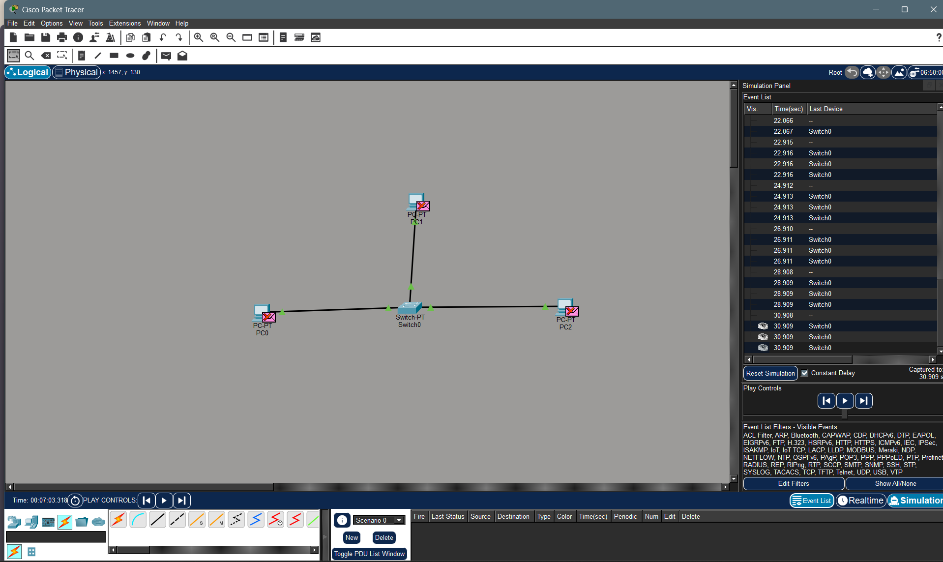

Explanation:
- PC0, PC1 and PC2 represent the hosts in the network.
- Switch0 is the central networking device connecting all three hosts.
- Each PC is connected to the switch through an Ethernet link.
- The green indicators on the links show that the connections are active.
- The experiment is running in Simulation Mode, which allows the movement of network packets to be observed step-by-step.
- The Simulation Panel on the right displays the events generated during communication.
- The event list contains packets associated with Switch0, showing that the switch is processing and forwarding the traffic.
- When PC0 sends a ping to PC1 after its ARP cache is cleared, PC0 first needs to discover PC1's MAC address.
- Therefore, an ARP Request is generated before the actual ICMP ping communication.
- PC1 responds with an ARP Reply, providing its MAC address.
- After this resolution, the ICMP packets used by ping can be delivered to PC1.
Result:
The LAN was successfully created using three hosts and a switch in Cisco Packet Tracer.

4. Develop a simple network consisting of two PCs connected through a router in Cisco Packet Tracer. Configure the required IP addresses and test connectivity using the ping command. Capture the ICMP traffic using Wireshark and identify the Echo Request and Echo Reply messages. Examine important ICMP fields such as Type, Code, Identifier, and Sequence Number, and calculate the Round Trip Time (RTT). Discuss how ICMP assists in network troubleshooting and connectivity verification.

Aim:
To Develop a simple network consisting of two PCs connected through a router in Cisco Packet Tracer. Configure the required IP addresses and test connectivity using the ping command. Capture the ICMP traffic using Wireshark and identify the Echo Request and Echo Reply messages. Examine important ICMP fields such as Type, Code, Identifier, and Sequence Number, and calculate the Round Trip Time (RTT). Discuss how ICMP assists in network troubleshooting and connectivity verification
Procedure:
- Open Cisco Packet Tracer and create a network with two PCs and one router.
- Connect PC1 to Router and Router to PC2 using Copper Straight-Through cables.
- Configure PC1 with:
- IP Address: 192.168.1.2
- Subnet Mask: 255.255.255.0
- Default Gateway: 192.168.1.1
- Configure PC2 with:
- IP Address: 192.168.2.2
- Subnet Mask: 255.255.255.0
- Default Gateway: 192.168.2.1
- Configure the router interfaces:
- G0/0 → 192.168.1.1
- G0/1 → 192.168.2.1
- Enable both interfaces using the no shutdown command.
- Verify the router interfaces using the command:
show ip interface brief
- Open PC1 → Desktop → Command Prompt and use the command:
ping 192.168.2.2
- Check whether Echo Request and Echo Reply messages are received successfully.
- Open Wireshark and start capturing network packets while performing the ping operation.
- Apply the filter icmp in Wireshark to display only ICMP packets.
- Select an Echo Request packet and note the Type, Code, Identifier, and Sequence Number fields.
- Select the corresponding Echo Reply packet and compare its ICMP fields with the request.
- Calculate the Round Trip Time (RTT) by subtracting the Echo Request timestamp from the Echo Reply timestamp.
- Analyze the ICMP packets to verify network connectivity and understand how ICMP helps in troubleshooting communication problems.
- Record the obtained ping results, ICMP fields, and RTT in the observation section.
Implementation:

Step 1:

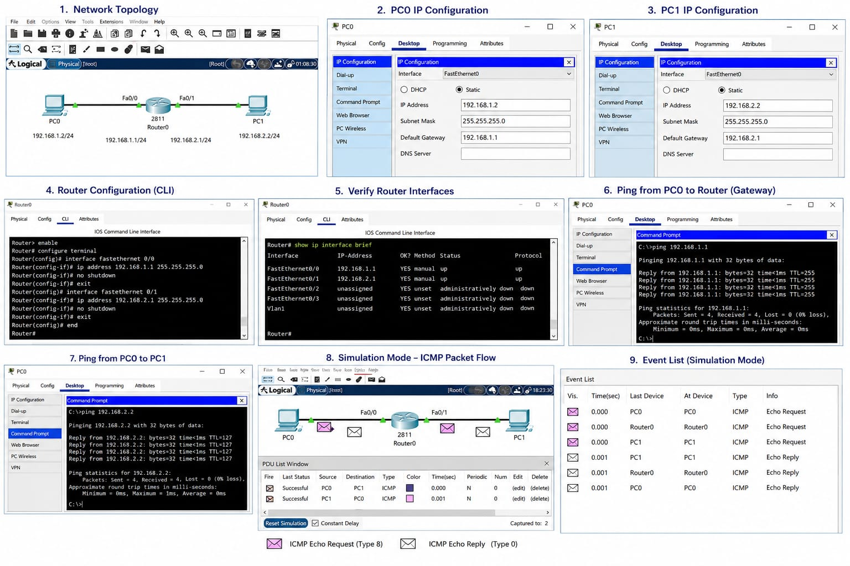

Explanation:

  - Network Topology

The first step creates the basic network.

- Two PCs (PC0 and PC1) are connected to one router (Router0).
- PC0 is connected to FastEthernet0/0 of the router.
- PC1 is connected to FastEthernet0/1 of the router.
- Two different networks are used:
  - PC0 network: 192.168.1.0/24
  - PC1 network: 192.168.2.0/24

IP Addresses
Device | IP Address
PC0 | 192.168.1.2
Router Fa0/0 | 192.168.1.1
Router Fa0/1 | 192.168.2.1
PC1 | 192.168.2.2
Step 2:



Explanation:

- PC0 IP Configuration
In this step, the IP address of PC0 is configured.
Go to:
- PC0 → Desktop → IP Configuration
- Enter:
- IP Address: 192.168.1.2
- Subnet Mask: 255.255.255.0
- Default Gateway: 192.168.1.1

- PC0 belongs to the 192.168.1.0 network. The router's 192.168.1.1 address is used as the gateway to reach other networks.

Step 3:



Explanation:

- PC1 IP Configuration
- In this step, the IP address of PC1 is configured.
Go to:
- PC1 → Desktop → IP Configuration
- Enter:
- IP Address: 192.168.2.2
- Subnet Mask: 255.255.255.0
- Default Gateway: 192.168.2.1
PC1 belongs to the 192.168.2.0 network. The router's 192.168.2.1 address acts as the gateway for PC1.

Step 4:


Explanation:

- Router Configuration (CLI)

- In this step, the two router interfaces are configured.
- Open:
Router0 → CLI
enable → enters privileged mode.
  - configure terminal → enters configuration mode.
  - interface fastethernet 0/0 → selects the interface connected to PC0.
  - ip address → assigns an IP address to the interface.
  - no shutdown → activates the interface.
  - interface fastethernet 0/1 → selects the interface connected to PC1.

The router now has an interface in each network and can route packets between them.

Step 5:


Explanation:

Verify Router Interfaces
The command:
show ip interface brief
is used to check the router interfaces.

The up/up status means:
- The interface is enabled.
- The physical connection is active.
- The router can communicate through that interface.
Therefore, both router connections are working correctly.

Step 6:

Explanation:

- ping from PC0 to Router
Open:
PC0 → Desktop → Command Prompt
Type:
ping 192.168.1.1

- This test checks whether PC0 can communicate with its default gateway, which is the router.
Since all four packets are received:
Packets Sent = 4
Received = 4
Lost = 0
The connection between PC0 and Router0 is successful.

Step 7:


Explanation:

Ping from PC0 to PC1
Now PC0 is used to test communication with PC1.
In:
PC0 → Desktop → Command Prompt
type:
ping 192.168.2.2
The image shows:
Reply from 192.168.2.2
with 4 packets received and 0% packet loss.

This confirms that PC0 can communicate with PC1 through the router.

Step 8:


Explanation:

Simulation Mode – ICMP Packet Flow
This is an important step for your experiment.
- In Cisco Packet Tracer, click:
- Simulation at the bottom-right.
- Then perform the ping again.
- You will see packet envelopes moving:
- PC0 → Router0 → PC1
- and then returning:
- PC1 → Router0 → PC0
- The purple envelope represents:
- ICMP Echo Request
- The white envelope represents:
- ICMP Echo Reply

Step 9:

Explanation:

Event List – Simulation Mode
The Event List shows the ICMP packets generated during the ping.
Your image shows entries such as:
Device | Type | Information
PC0 | ICMP | Echo Request
Router0 | ICMP | Echo Request
PC1 | ICMP | Echo Request
PC1 | ICMP | Echo Reply
Router0 | ICMP | Echo Reply
PC0 | ICMP | Echo Reply

This shows the complete journey of the ICMP packets.
Echo Request
PC0 → Router0 → PC1
Echo Reply
PC1 → Router0 → PC0
This confirms that the router successfully forwards the ICMP packets between the two networks.

RESULT:

Thus, the network was successfully configured and connectivity between PC0 and PC1 was verified using ICMP ping. The Simulation Mode displayed the ICMP Echo Request (Type 8) and Echo Reply (Type 0), demonstrating how ICMP is used for connectivity verification and network troubleshooting.

RUBRICS FOR CALCULATION

Criteria | Weightag  e | Level 4 –  Exemplary | Level 3 –  Proficient | Level 2 –  Developing | Level 1 –  Beginning
Understandin g of Concepts | 25 | Demonstrates thorough  understanding and effectively  integrates multiple concepts/technologi  es | Good understanding with proper  integration of most concepts | Basic understanding  ; limited or partial integration | Poor understanding  ; unable to integrate concepts
Experimental Design | 30 | Well-planned, systematic  implementation  with optimal solution | Correct implementati  on with minor issues | Basic implementati  on with errors or  inefficiencies | Incorrect or incomplete  implementati on
Use of Tools | 20 | Effective and advanced use of  tools/technologies with proper configuration | Appropriate use of tools  with correct execution | Limited or inconsistent use of tools | Incorrect or minimal use of tools
Analysis of Results | 15 | Insightful analysis with accurate  interpretation and validation of results | Good  analysis with reasonable interpretation | Basic analysis with limited insights | Poor or incorrect  analysis of results
Documentati on | 10 | Clear, wellstructured  documentation with diagrams, code, and  results | Organized documentatio n with  necessary details | Basic documentatio n with  missing details | Poor or incomplete  documentatio  n

